Labor Markets Problem Set

1. The table below shows data for the production of Avocados for an individual firm.
Number of workers | Number of Avocados
0 | 0
1 | 70
2 | 126
3 | 168
4 | 196
5 | 210

Given this data, what is the marginal product of labor when quantity increases from 1 by one unit?

2. The table below shows data for the production of Avocados for an individual firm operating in a perfectly competitive market. Suppose that the price of Avocados is $3.
Number of workers | Number of Avocados
0 | 0
10 | 150
20 | 270
30 | 360
40 | 420
50 | 450

Given this data, complete the table:
Number of Workers | Marginal Product of Labor (MPL) | Value of the Marginal Product of Labor (VMPL)
0 | - | -
10
20
30
40
50

3. The table below shows data for the production of Avocados for an individual firm operating in an imperfectly competitive market.
Number of workers | Number of Avocados | Marginal Revenue
0 | 0 | 22
10 | 150 | 21
20 | 270 | 20
30 | 360 | 19
40 | 420 | 18
50 | 450 | 17

Given this data, complete the table:
Number of Workers | Marginal Product of Labor (MPL) | Marginal Revenue Product of Labor (MRPL)
0 | - | -
10
20
30
40
50

4. Suppose that the employer is hiring workers in a perfectly competitive market where the market equilibrium wage is $8.
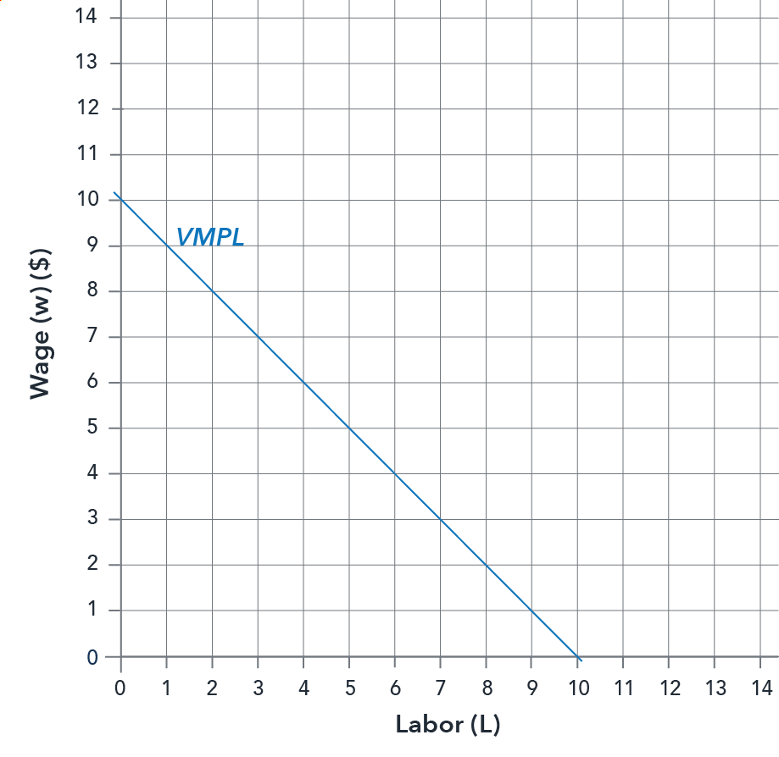
How many workers will be hired at this wage?

5. Suppose that a firm has market power in their output market. Suppose that the employer is hiring workers in a perfectly competitive market where the market equilibrium wage is $15.
The graph below shows the labor demand curve for this firm.
Note: VMPL stands for Value of the Marginal Product of Labor. MRPL stands for Marginal Revenue Product of Labor.
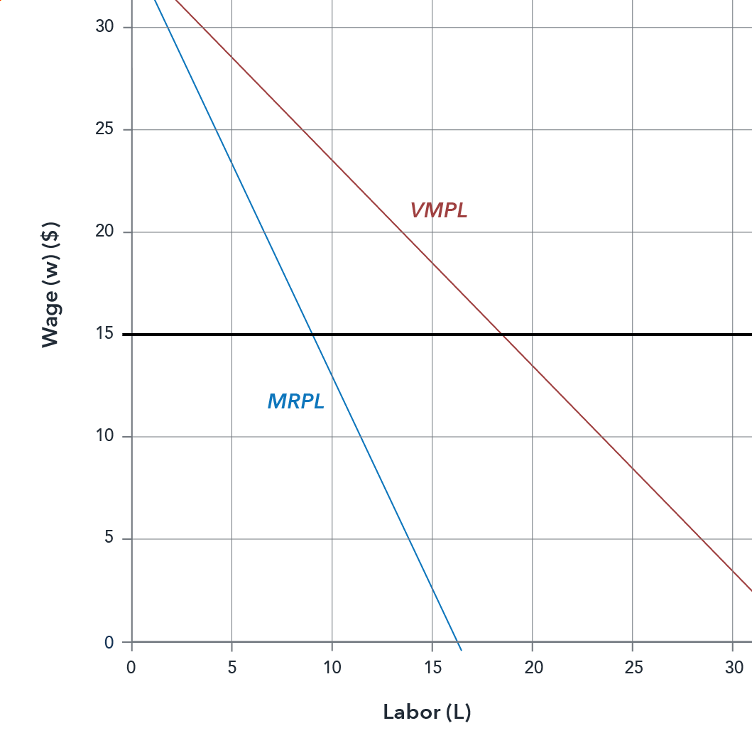
What is the number of workers that this firm will hire?
- 18.33
- 6.17
- 9.17

6. Suppose that a firm has market power in their output market. Suppose that the employer is hiring workers in a perfectly competitive market where the market equilibrium wage is $15.
The graph below shows the labor demand curve for this firm.
Note: VMPL stands for Value of the Marginal Product of Labor. MRPL stands for Marginal Revenue Product of Labor.
What is the number of workers that would be hired if this firm would be selling its output in a perfectly competitive market?
- 18.33
- 6.17
- 9.17

7. The graph below shows the supply and demand curves for labor in a perfectly competitive market.
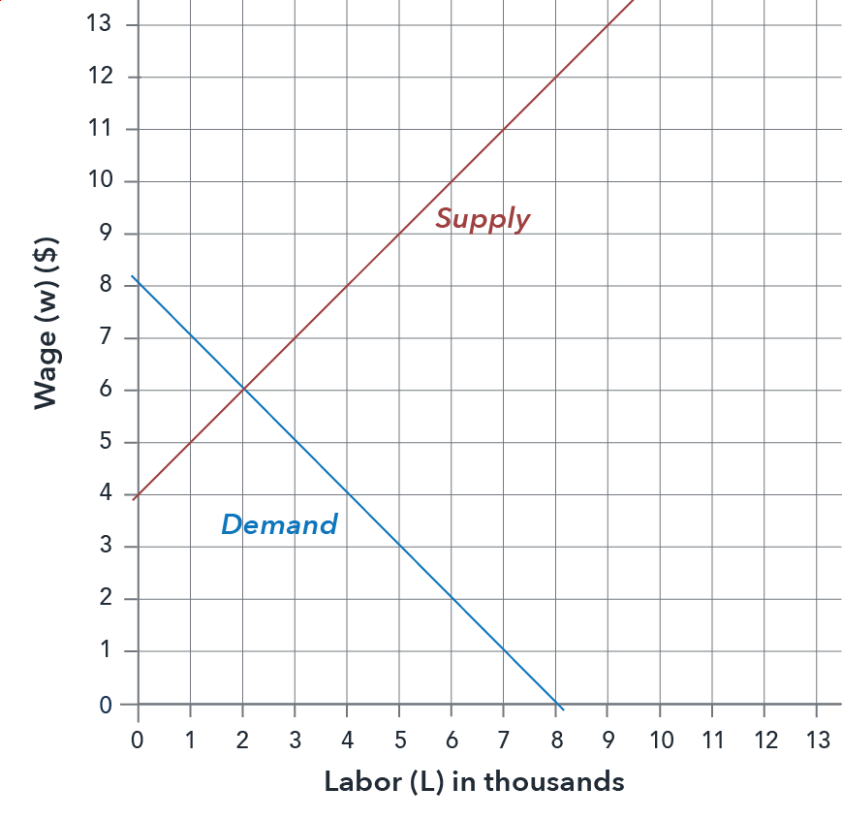
What is the equilibrium quantity of workers hired in this market?

8. The graph below shows the supply and demand curves for labor in a perfectly competitive market.

What is the equilibrium wage that will prevail in this market?

Use the following information to answer questions 9 through 12:

The graph below shows supply and demand for labor in a monopsonistic labor market.
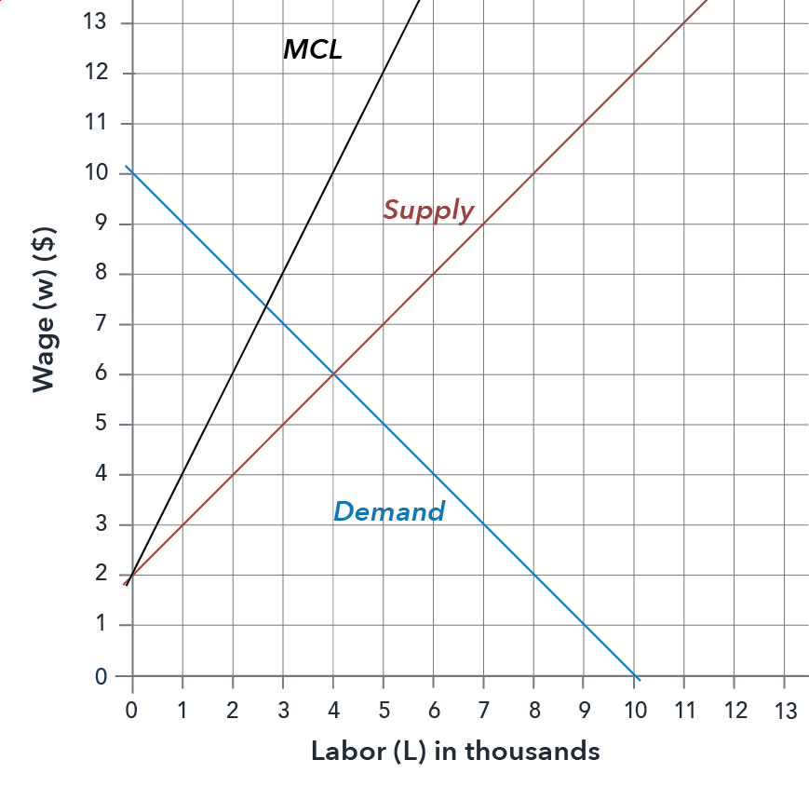
9. What is the number of workers that this firm will hire?
- 2.67 thousand
- 4 thousand
- 6 thousand
- 1.67 thousand

10. What is the wage that this firm will pay their workers?
- 2.67 dollars/hr
- 4 dollars/hr
- 6 dollars/hr
- 4.67 dollars/hr

11. What is the number of workers that would be hired if this were a perfectly competitive labor market?
- 2.67 thousand
- 4 thousand
- 6 thousand
- 4.67 thousand

12. What is the wage that would be paid if this were a perfectly competitive labor market?
- $2.67
- $4
- $6
- $4.67

This assignment by Lumen Learning is licensed under a Creative Commons Attribution 4.0 International License.

